Practical No. 5
Aim : ALP for signed division of two 16-bit numbers
Name : Danish Altaf Solkar Class : CO - B
Enrolment no. : 24111590805 Batch : 2

Code :-
assume cs:code
assume ds:data
data segment
num1 DW 1234H
num2 DW -1000H
quo DW ?
rem DW ?
data ends
code segment
start:
MOV AX,data
MOV DS,AX
MOV AX,0000H
MOV AX,num1
MOV BX,num2
IDIV BX
MOV quo,AX
MOV rem,DX
INT 03H
code ends
end start

OUTPUT :-
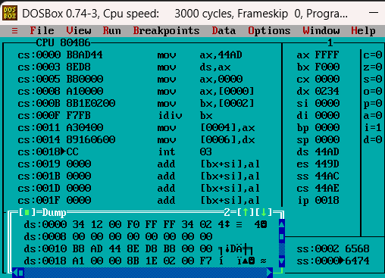

Process related  (15) | Product related  (10) | Total Marks  (25) | Signature

